**Lab 02**

**Objectives:**

This lab will enable students to:

* + Learn top down and bottom up design methodologies
  + Data flow level modeling

**TASK 1:**

**4 bit Ripple Carry Adder**

**Block Diagram:**

Following is the block diagram of a 4 bit Ripple Carry Adder.

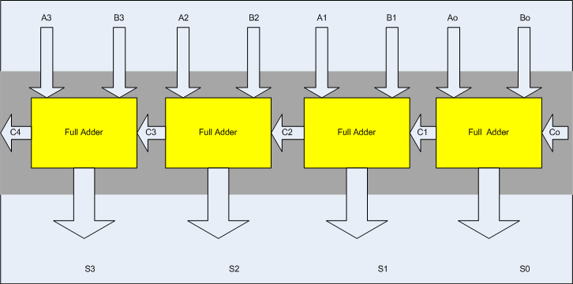

**I/O Connection:**

Ground “Co” Permanently and connect S0-S3 with four LEDs also connect C4 to another LED.

**Steps for task 1a:**

The following steps should be performed while designing a 4 bit RCA adder

**ModelSim:**

1. First implement a Full adder using data gate level modeling.
2. Simulate the Full adder with a test bench.
3. Instantiate the Full adder four times and connect the circuit as shown.
4. Now again write a test bench and simulate the 4 bit RCA.

**Xilinx:**

1. Make new project in Xilinx and add the files that you simulated in ModelSim.
2. Add User Constraint File inputs should be locked with the switches, C0 should be permanently “0” while S0-S4 and C4 with LEDS

**Task 1b:**

Design the 4 bit full adder using data flow level modeling.